Installation of the Samos Wallet English Manual

Inhoud

A. Installation of the Samos Wallet 1

B. Send Samos 7

C. Check transactions 8

D. Back-up your Wallet 8

E. Load a back-uped Wallet 9

# Installation of the Samos Wallet

1. Go To the Samos website : <https://www.samos.io>
2. Click on Downloads and go to Wallet

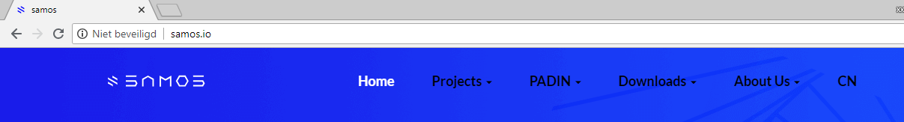

1. Choose which Wallet you need for your OS or mobile phone

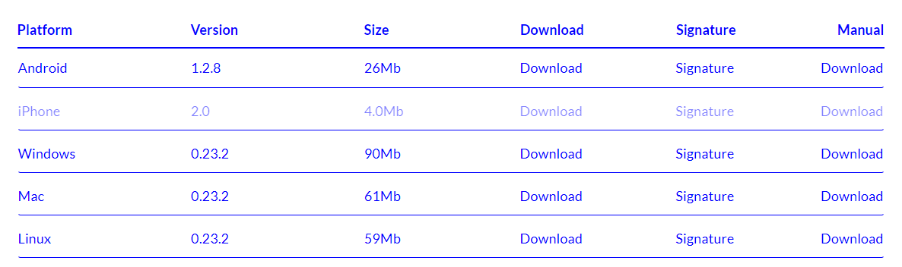

1. Download the file you need.
2. Open the Installer that you downloaded.
3. Choose to who you want to install the Wallet
   1. Anyone who uses this computer
   2. Only for me
4. Click next
5. Choose a installation map and click install
6. 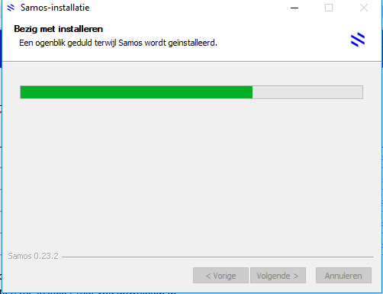

The above picture is in dutch.

1. Select Start Samos and click on Complete.

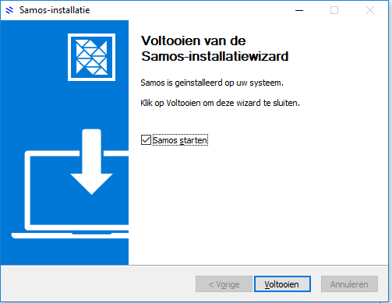

1. When you open the Samos application you need to make a new wallet. Give your wallet a name and **NOTE the Seed (Don’t place it on your computer!) Note it on a paper and hide it in a good place!**
2. 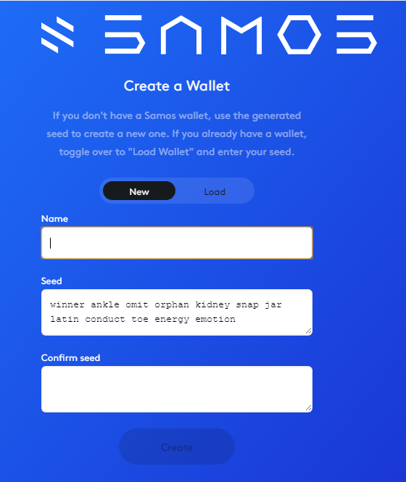
3. To confirm the seed type it again in the textbox below. And click on create.
4. 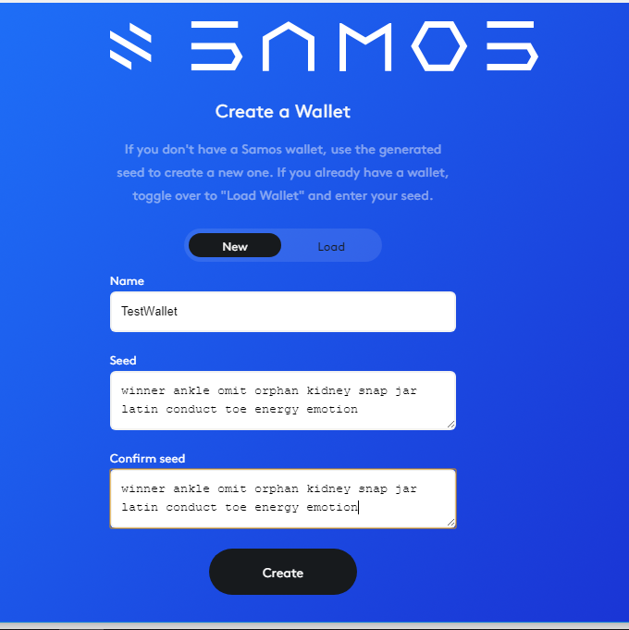
5. In the next screen select, it’s safe, i swear and click on Continue.
6. 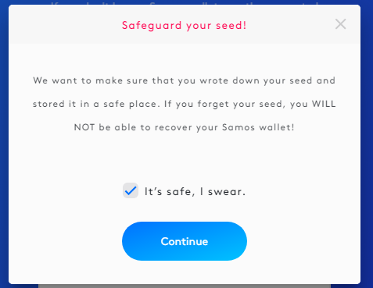
7. In the next screen type in a password and click on Finish
8. 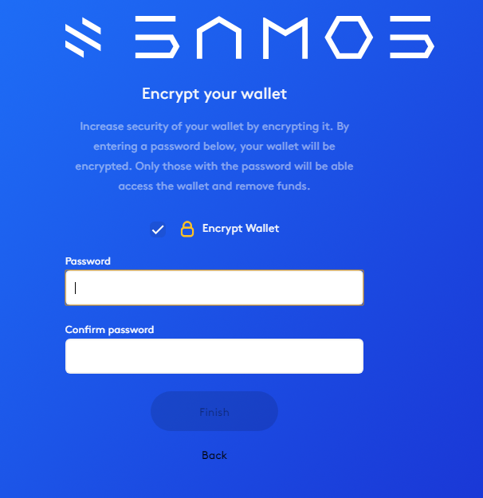
9. Congratz! You made your own wallet!!

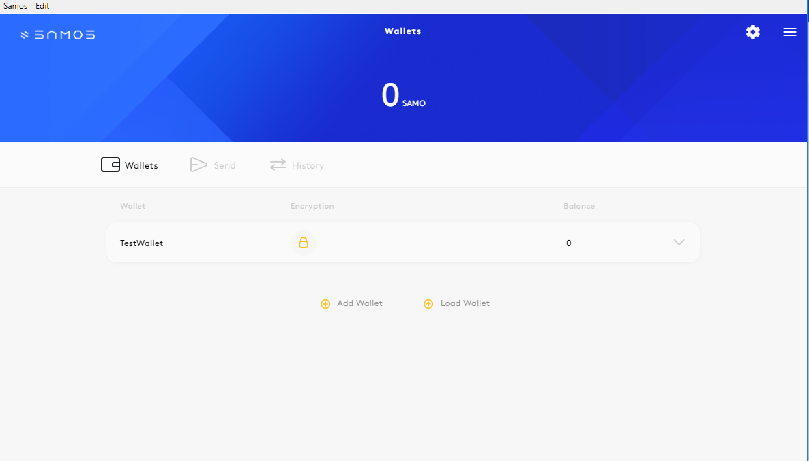

# Send Samos

1. To send some Samos click on the ‘Send’ button in your Wallet
2. 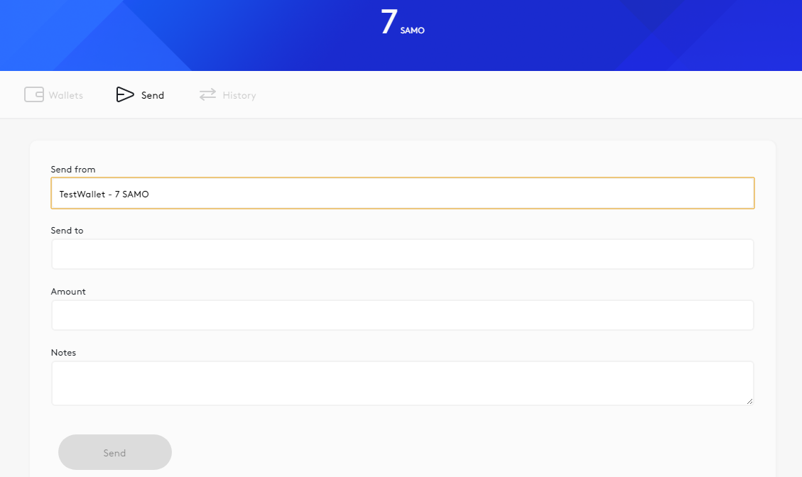
3. Provide the data where is asked for:
   1. Send From -> The wallet which you want to use to send Samos from
   2. Send to -> The wallet where you want to send the Samos to
   3. Amount -> The amount of Samos you want to transfer
   4. Notes -> Add a note for the Transaction ( A note typical for the transaction).
4. Click on Send
5. 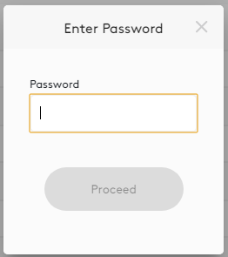
6. Enter the Password of the wallet you send your Samos from.
7. The Samos is now transfered to the other Wallet

# Check transactions

To see the transactions made from and to your wallets click on the History tab in your Wallet. See the Picture below:

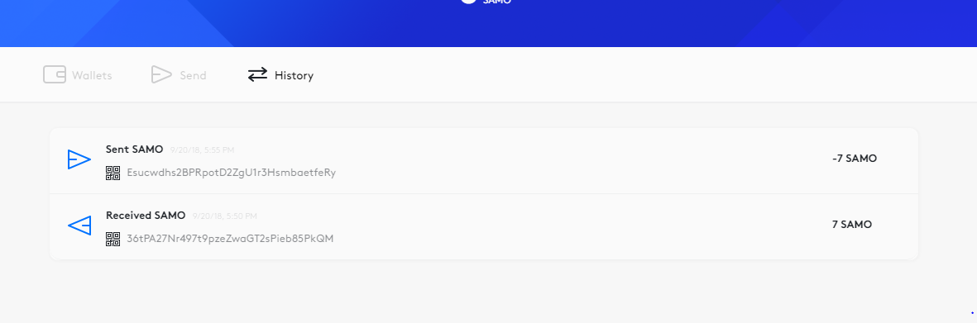

# Back-up your Wallet

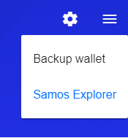

1. To backup your wallet click in your wallet at the right top on the 3 horizontal bars and click on Backup wallet.
2. The following Page pops-up
3. 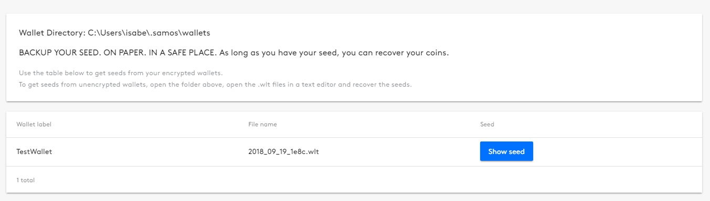
4. Click on “Show seed” and write it down!

# Load a back-uped Wallet

1. Go to the homepage of your Wallet and click on Load wallet
2. 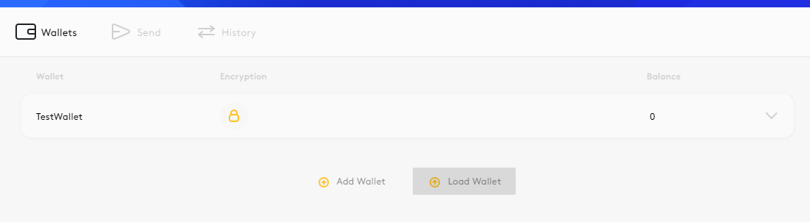
3. The next window pops-up
4. 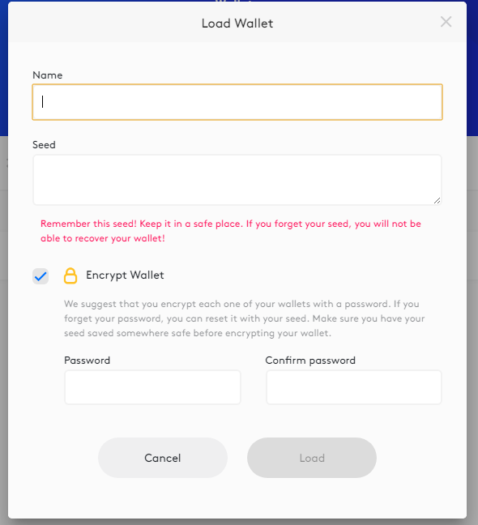
5. Fill in the Name of your Wallet and the Seed that you wrote down when you back-upped your wallet.
6. Think up a password and click load. Your Wallet will load again.

**When you install Samos again from scratch, than don’t make a new wallet but instead load the back-upped wallet.**